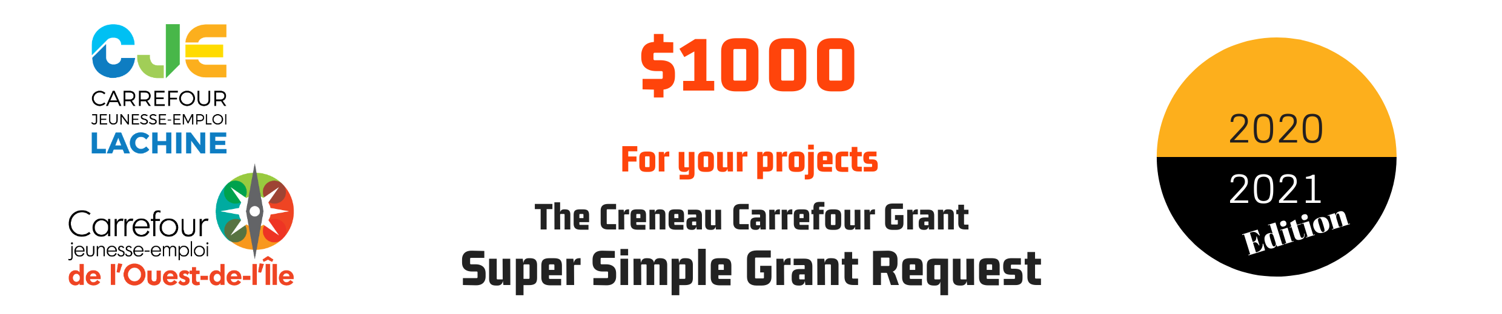

Staff member responsable for the projet : Cliquez ici pour entrer du texte.

School Name : Cliquez ici pour entrer du texte.

Working name of your project : Cliquez ici pour entrer du texte.

Description of your project : What? When? Why? How?
Cliquez ici pour entrer du texte.

Explain how your students will be involved in the creation, development and implementation of the project. Cliquez ici pour entrer du texte.

What benefits will come from this project? Cliquez ici pour entrer du texte.

Estimated amount requested : Cliquez ici pour entrer du texte.

Approximate start date of your project : Cliquez ici pour entrer du texte.

Deadline : October 23rd, 2020
Send by email to: s.asmar@cjeouestile.qc.ca

* Your project must take place between April 1st, 2020 and June 30th, 2021
* Only expenses incurred before March 16th, 2021 will be reimbursed.

